**USER-GUIDE**

* **Welcome page:** as soon as the user/client enters the platform, the page below is displayed



* **Create an account:** Register for a new account by providing your email address, password, and other required information.

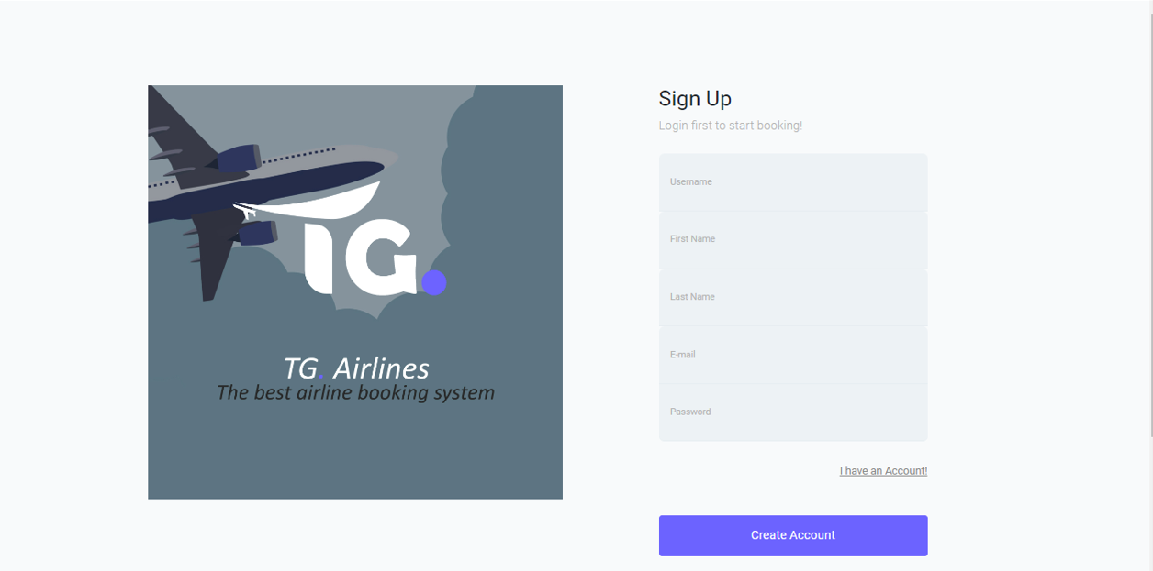

* **Login:** Once registered, log in to your account using your email address and password.

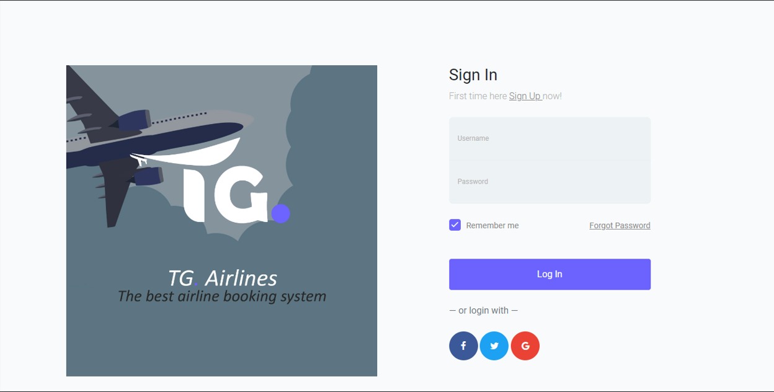

Once you’re logged in the page below appears

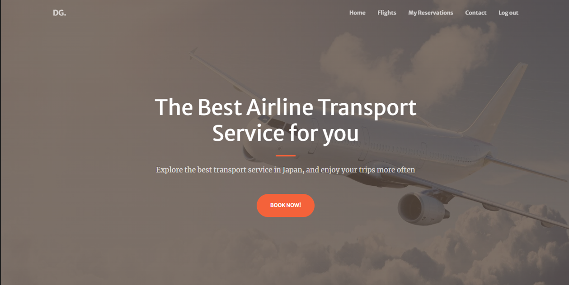

**Some App Features:**

**1. Booking Flights:**

* **View flight details:** Get detailed information about each flight, including departure and arrival times, aircraft type, and available classes.
* **Select your flight:** Choose the flight that best suits your needs and proceed to the booking process.
* **Choose your seats:** Select your preferred seats on the aircraft.
* **Enter passenger information:** Provide passenger details for each person traveling.
* **Payment:** Choose your preferred payment method and complete the payment process.

**2. View Booking History (Reservation Page):**

* Access your booking history by navigating to the "Reservations" section.
* View details of each booking, including flight information, passenger details, and booking status.
* Manage your bookings:
  + Modify or cancel your bookings within the specified timeframe.
  + Download e-tickets for confirmed bookings.

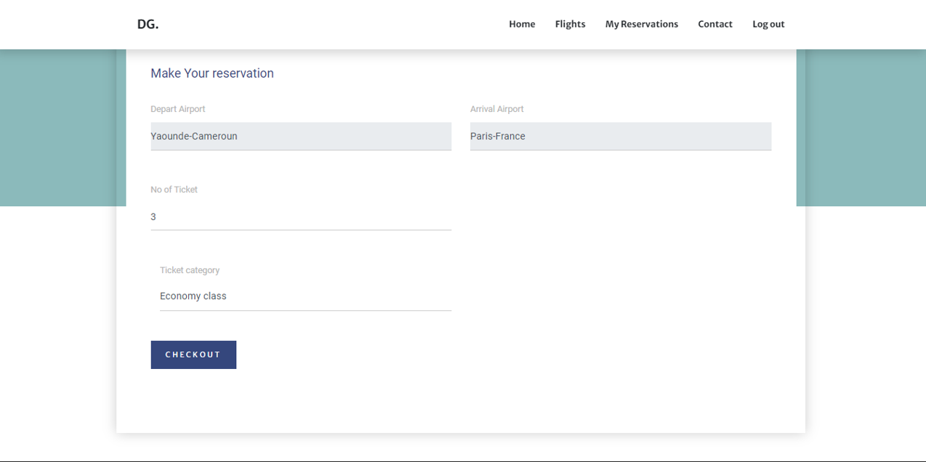

**3. Payment Page:**

* The payment page allows you to securely process your flight booking payments.
* Choose from various payment methods like credit cards, debit cards, or online wallets.
* Enter your payment information and complete the transaction.

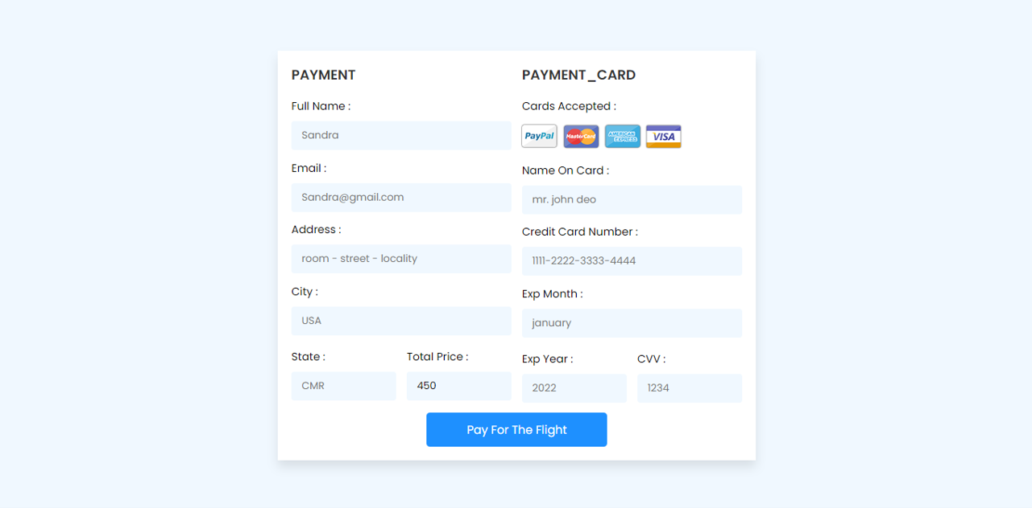

And the ticket is printed/ presented as follows:

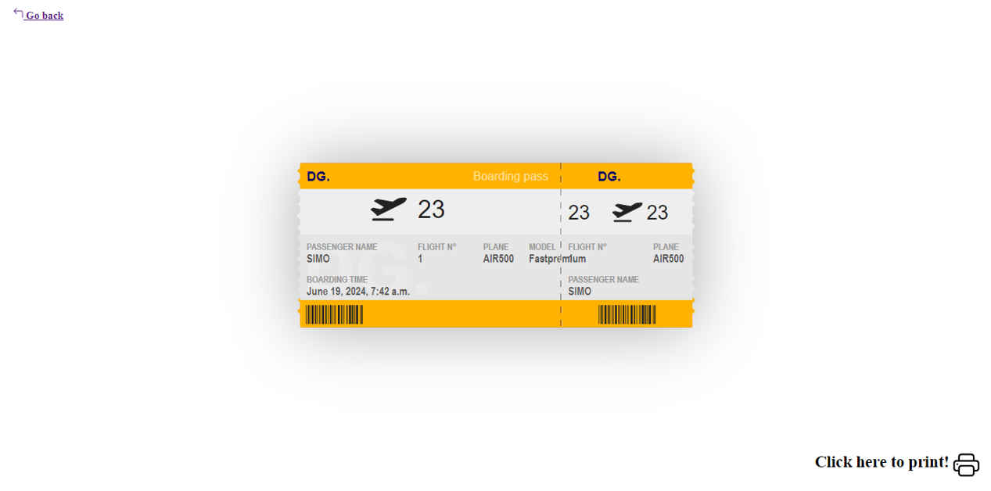

**4. View Available Flights:**

* Browse through all available flights offered by Darling Airlines.
* Use filters and search options to find flights based on your preferences.
* View flight details and compare different options before making a booking.

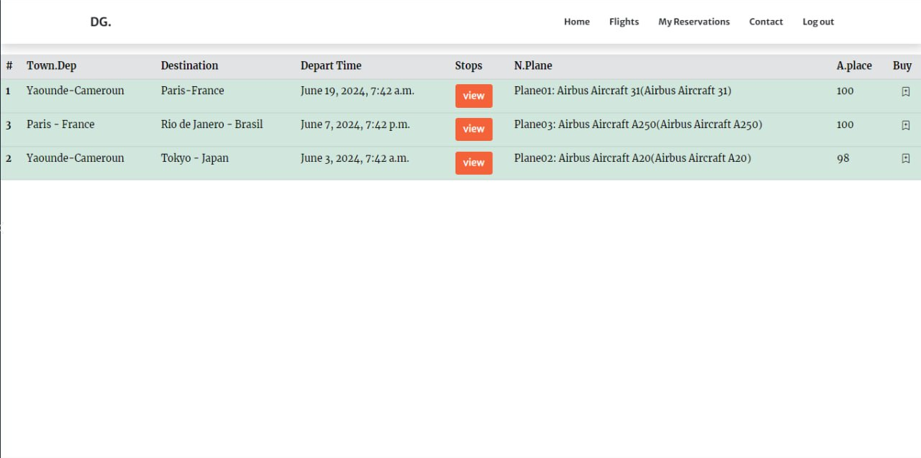

**5. Admin Dashboard (for Admins only):**

* Admins have access to a dedicated dashboard where they can:
  + Manage flight schedules and availability.
  + View booking reports and passenger information.
  + Handle customer inquiries and manage refunds.
  + Update app settings and configurations.

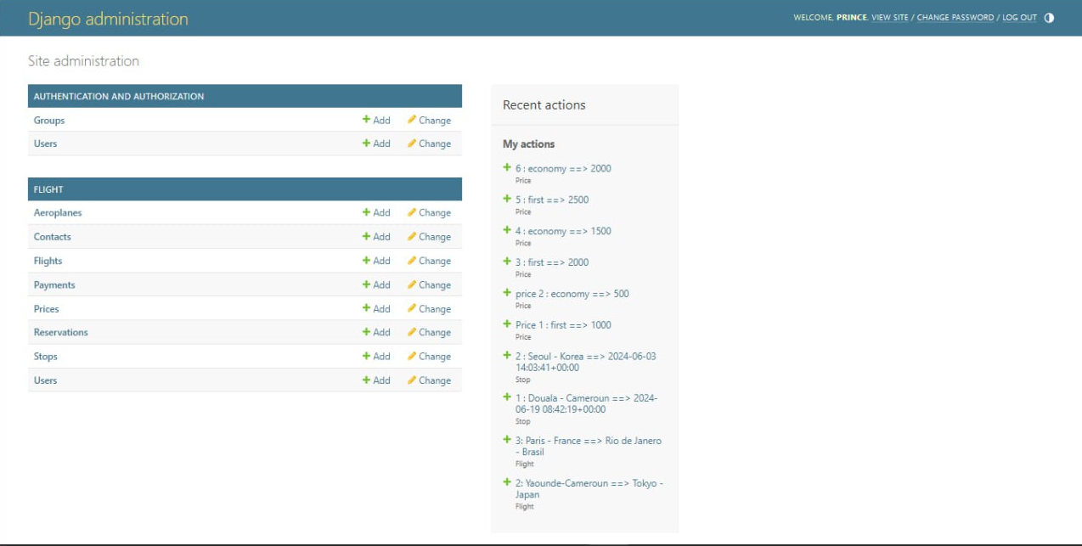

From the command line of the project’s directory, a backup file is present. It can restore the database from the backup file by running:

***python manage.py restore_db your_database_name_backup.sql***

The backup command itself is given by:

***python manage.py backup_db***

This will generate a backup file named darling_airline.sql in the project directory.

**PACKAGES IN DARLING-AIRLINES**

These lines represent a list of Python packages and their versions, likely used within a Django project (they can be seen in the *requirements.txt* file). Let's break down each package for a clearer understanding:

1. **asgiref==3.8.1:**
   * asgiref is used to enable asynchronous functionality in the flight management app, allowing it to handle real-time updates and push notifications more efficiently.
2. **Django==5.0.6:**
   * The core Django framework is used to build the flight management web application, providing features like routing, models, views, and templates.
3. **django-dbbackup==4.1.0:**
   * django-dbbackup is used to regularly backup the flight data, including information about flights, passengers, and bookings, to ensure data integrity and enable easy restoration if needed.
4. **psycopg2==2.9.9:**
   * psycopg2 is the adapter used to connect the Django application to a PostgreSQL database, which is likely chosen to handle the large amounts of flight data efficiently.
5. **pytz==2024.1:**
   * pytz is used to handle time zone-related functionality, such as displaying flight schedules and departure/arrival times in the correct time zones for users across different locations.
6. **sqlparse==0.5.0:**
   * sqlparse may be used to parse and manipulate SQL queries, particularly for complex database operations related to flight scheduling, availability, and booking.
7. **tzdata==2024.1:**
   * tzdata provides up-to-date time zone information, which is crucial for the flight management app to accurately display flight times and handle time zone-related business logic.

In the context of Darling-Airlines, these packages work together to provide a robust and feature-rich platform for managing flight operations. The asynchronous capabilities, database backup and restoration, PostgreSQL integration, and time zone handling are all essential for a flight management system to function effectively and reliably.

**CLASS DIAGRAM**

